**EECS 113**

**Final Project**

**Student1: Gaurav Venkatesh (28826069)**

**Student2: Mario Ruiz (46301389)**

**Introduction:**

Our project is based on the game Simon , the game itself is fairly simple. The game is based on memorization and rounds. After every round your score increments by 1. In the first round 1 out of 4 colors (red,blue,green,yellow) will blink. The user must press the corresponding button to represent the color. If the player is correct they move on to the next round in which the color sequence is incremented by 1 and now the player has to input the 2 colors the machine lit up. We have incorporated a sound with each light as well to make the game more interesting. After the player inputs the wrong sequence and essentially the player loses we send an email to the required gmail id with the score.

**Materials Required:**

The materials required to make the game are:

Raspberry pi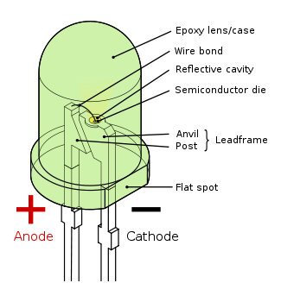

About 20-30 jumper wires

4 push button switches

4 LED(Light emitting diodes)

Breadboard and resistors

40-pin GPIO to Breadboard Interface Board

40-pin GPIO ribbon cable

Earphones

The cost of the raspberry pi 3 is $35 and the earphones are about $10. The remaining materials needed are included in a bundle for about $15. The total estimated bill of materials for our project comes to around $60. During this project we did not have a lot of trade offs or anything since we used basic components.The only thing we did have problem was blinking of lights more than the required amount, after reading through we realised we needed to just provide it with sleep and we solved that problem

**Structure of Source Code:**

The whole reason we chose this project was to get used to the raspberry pi and to get used to python on the machine. We have little experience with python since we have been using C and Java for the most part and wanted to learn how to code on it and make something original rather than simply just calling libraries and use code that is available online. The whole code was written by us, by only looking up from the previous assignments and raspberrypi.org on how to use the gpiozero library which we used for turning on the leds and taking input from the buttons.

